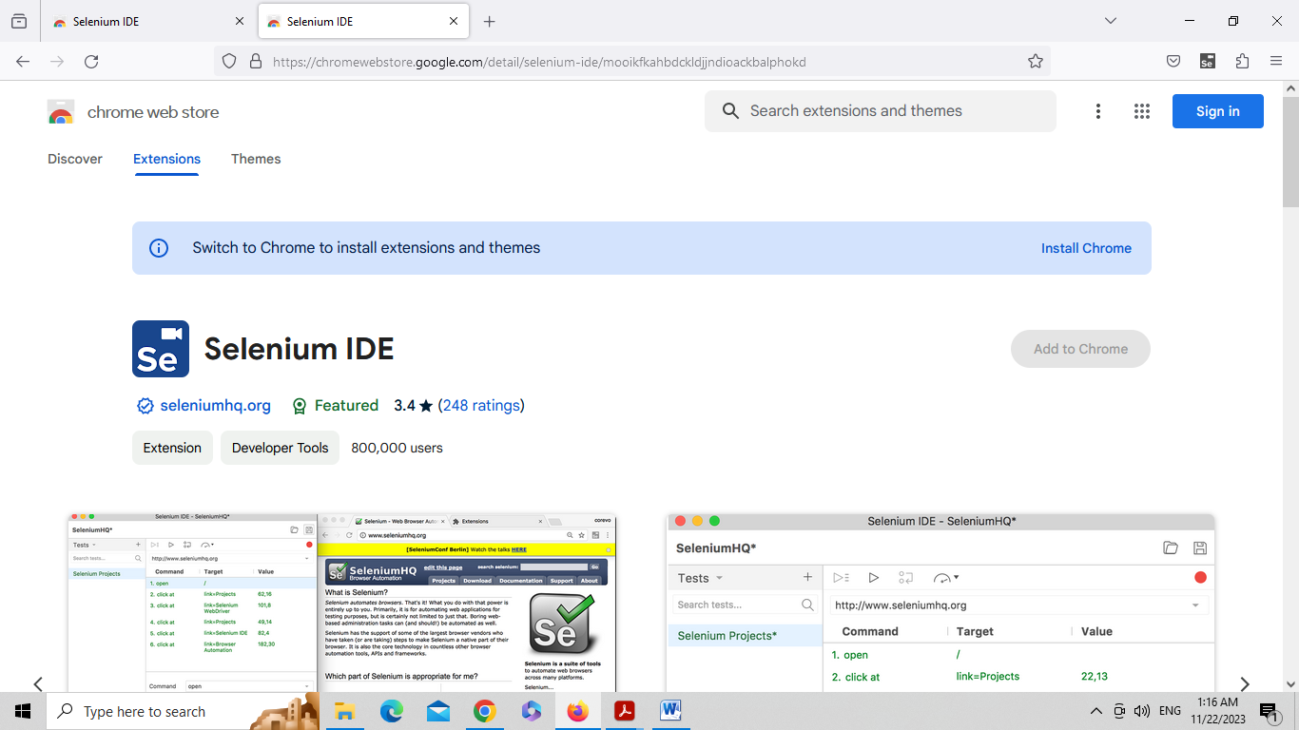

Step 1: Click on the Selenium IDE button in top right corner of Mozilla Firefox browser.

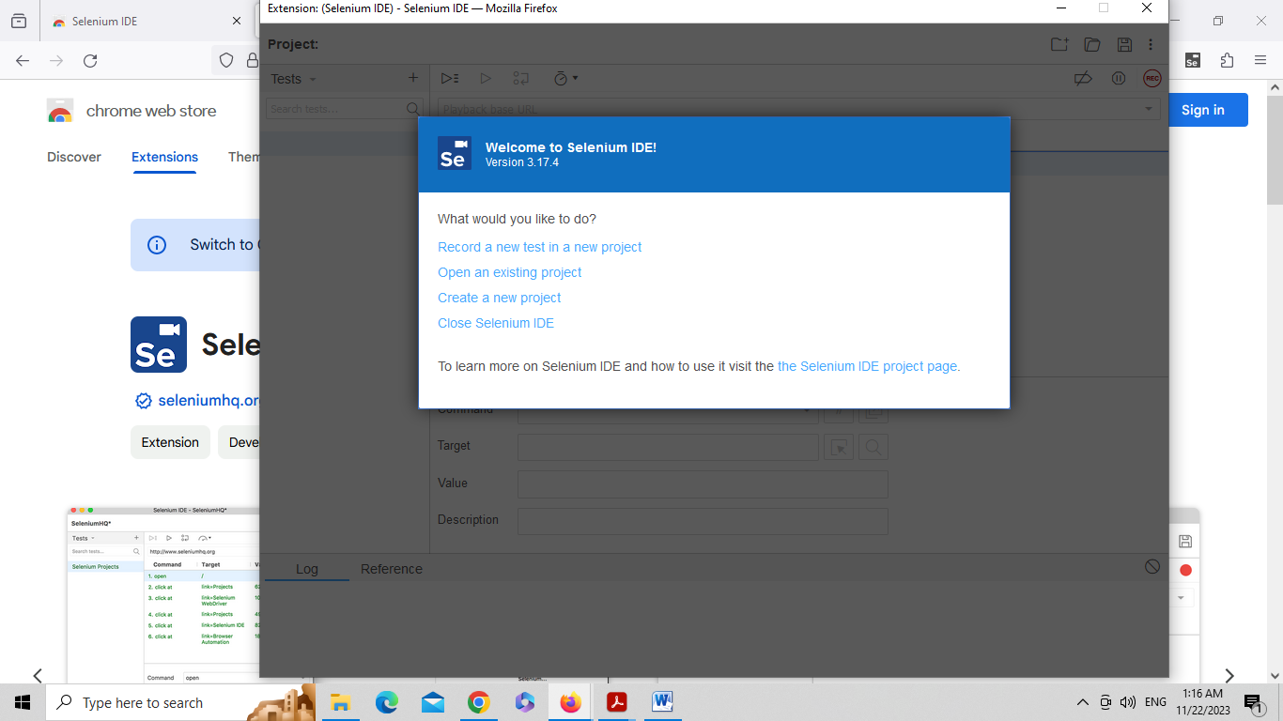

Step 2: Click on ‘Create new project’. Enter name for the project. Let us say ‘Project1’

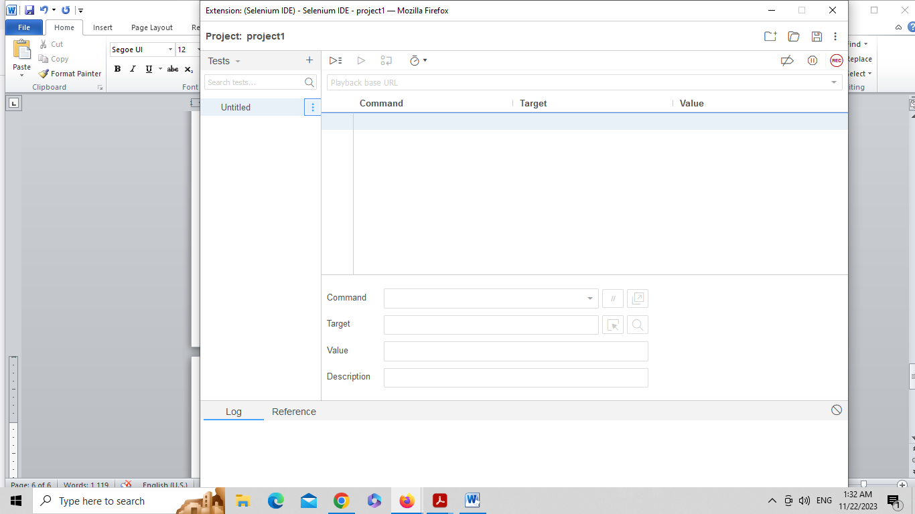

Step 3: Rename the existing test case

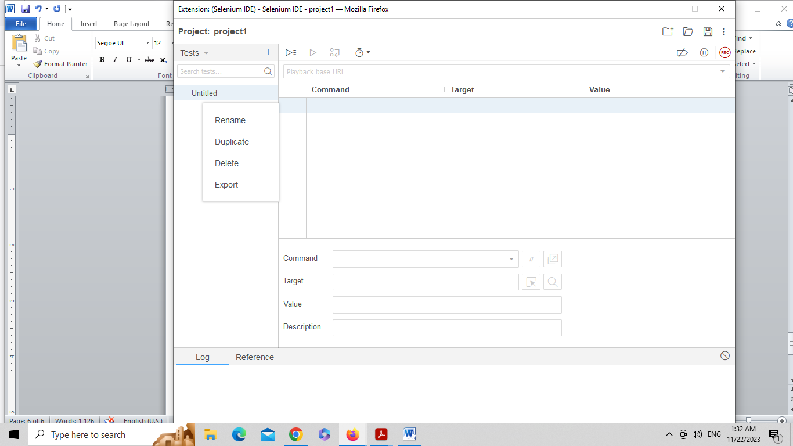

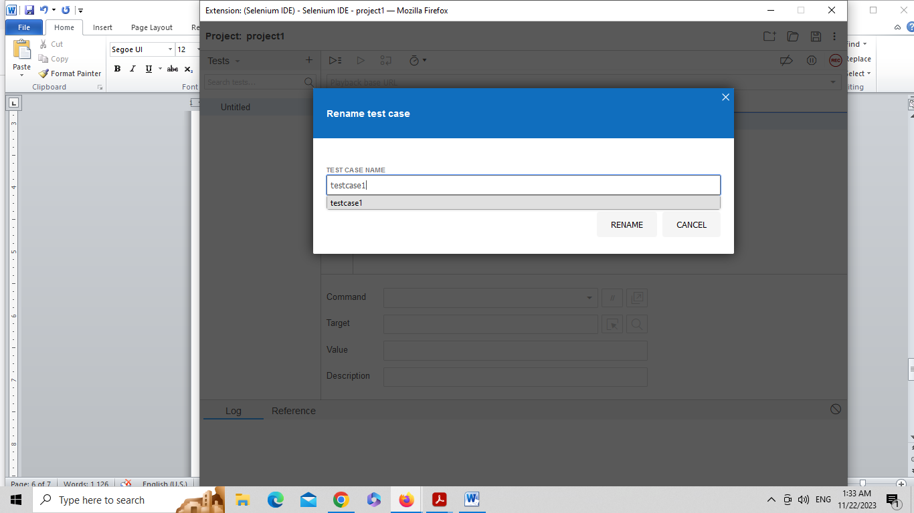

Step 4: Enter following commands

Test case 1

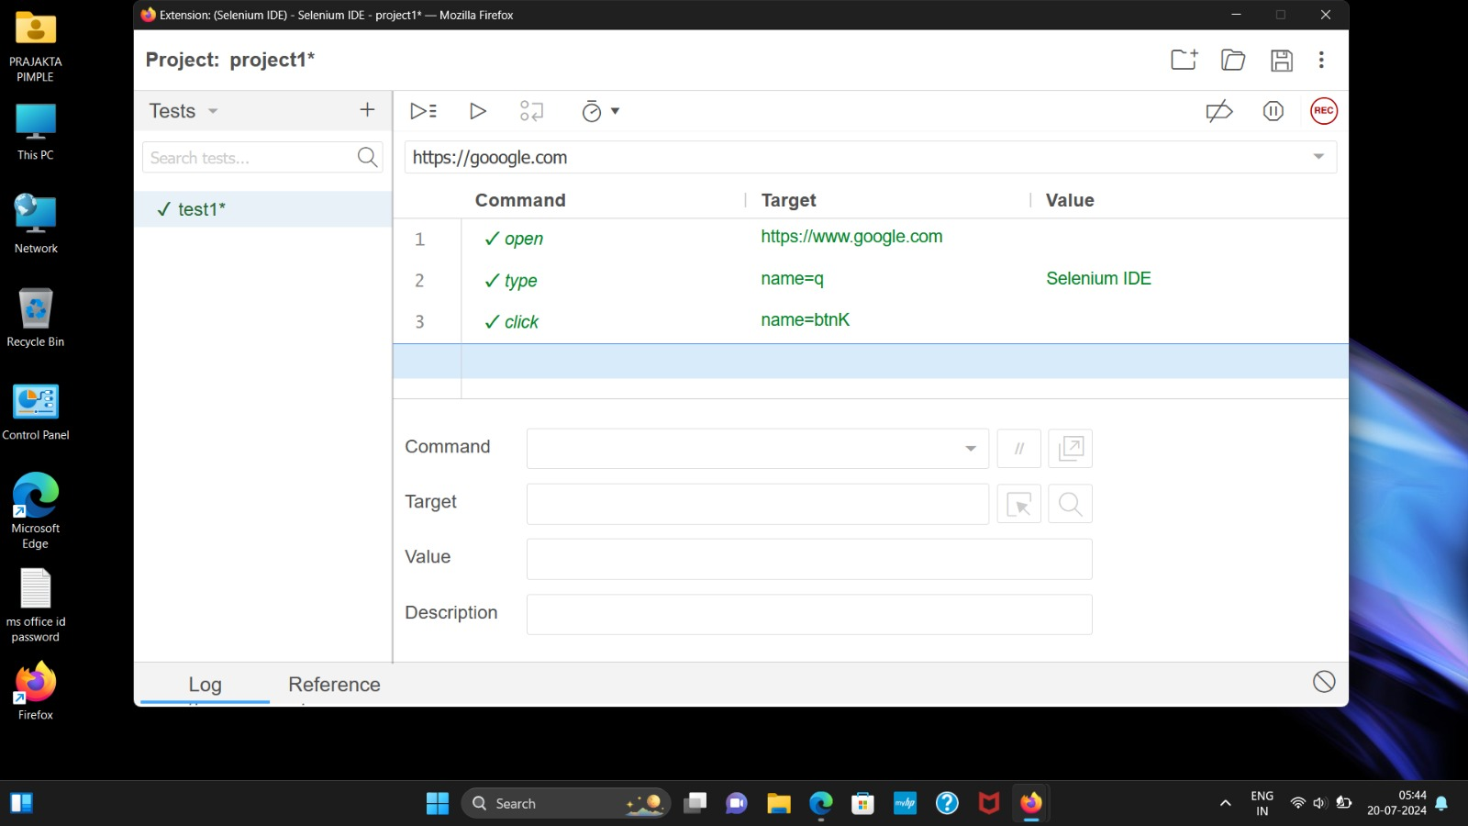

Step 5: Add new test case

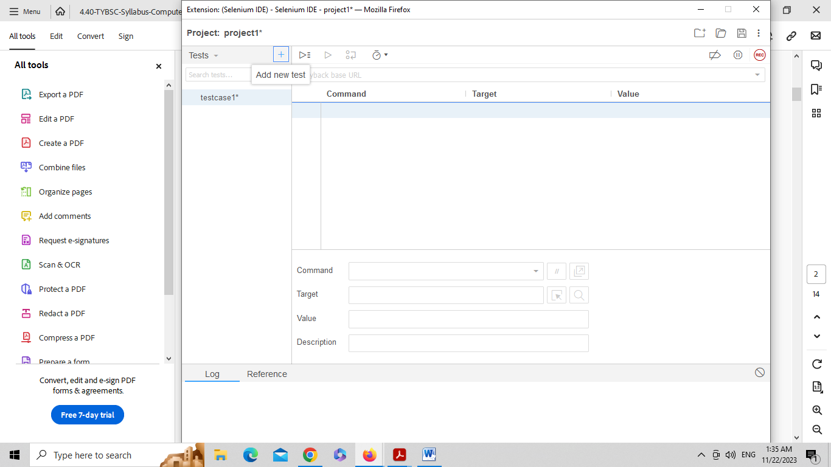

Test case 2

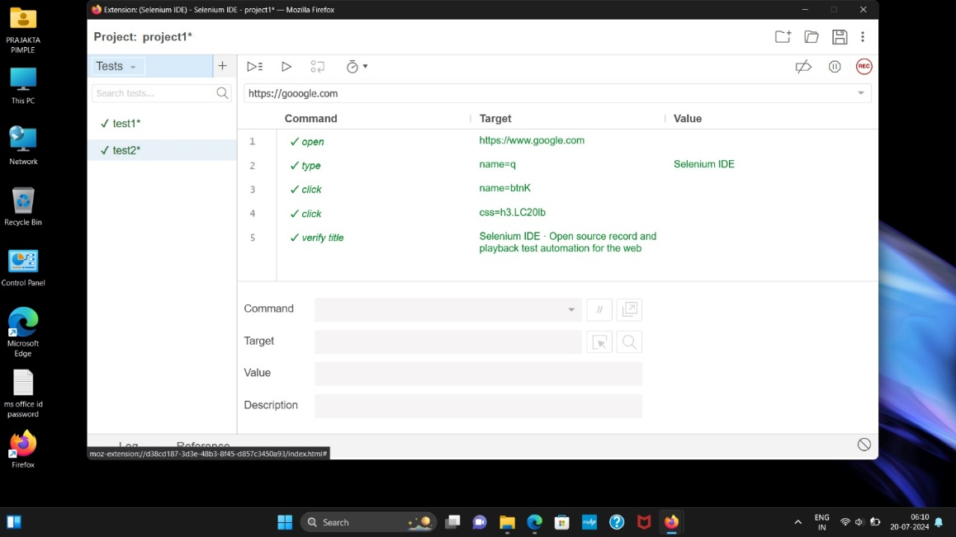

Step 6: Add new test case

Test case 3

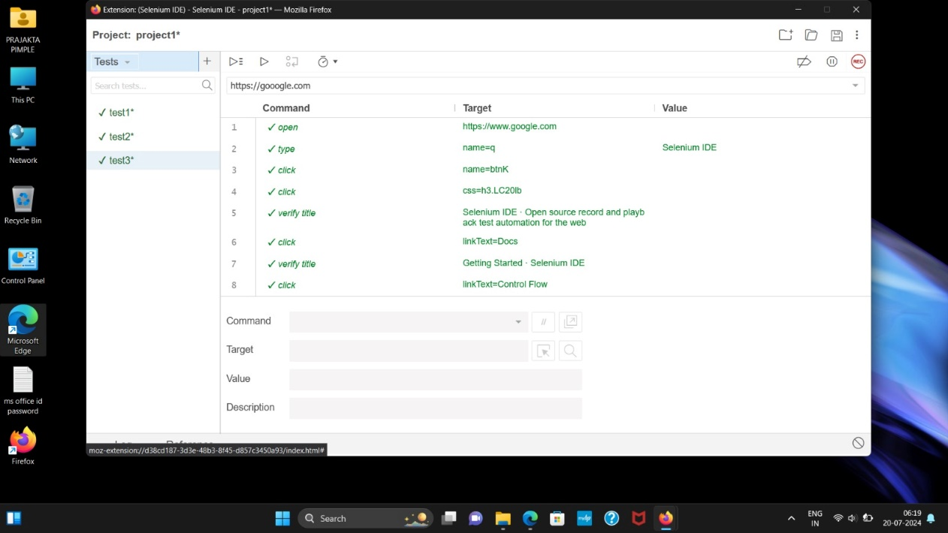

Step 7: Add new test case

Test case 4

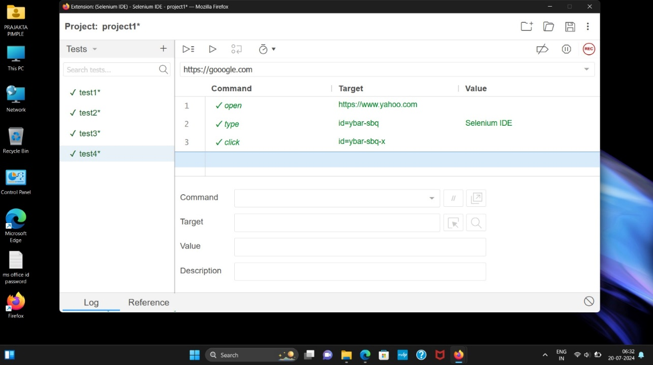

Step 8: Add new test case

Test case 5

